20CYS403 – Web Application Security
XML LAB

Ponvedica M S
CB.SC.U4CYS23034
- Created 2 table – students and subject_marks under the database named studentxml
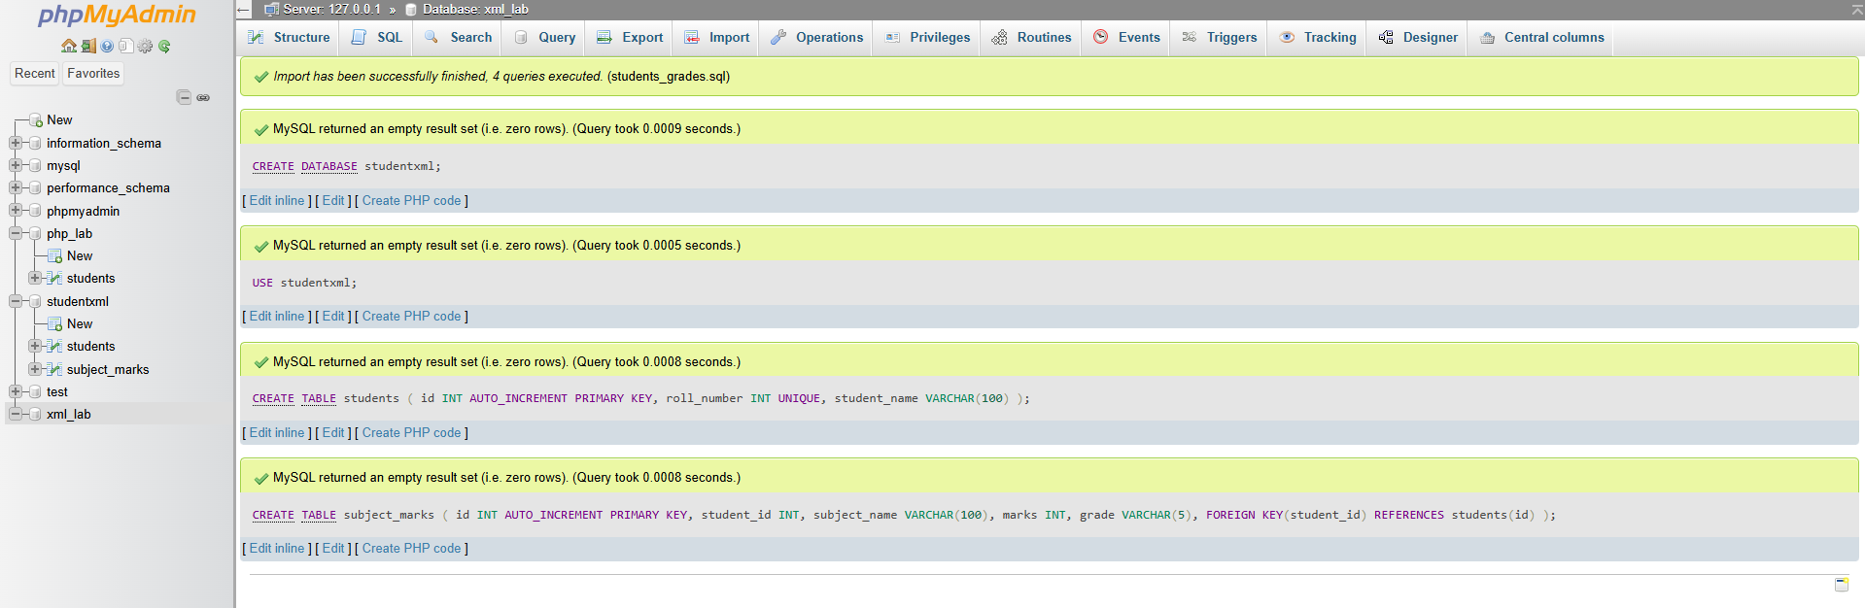
- UI for the validation and calculating the marks
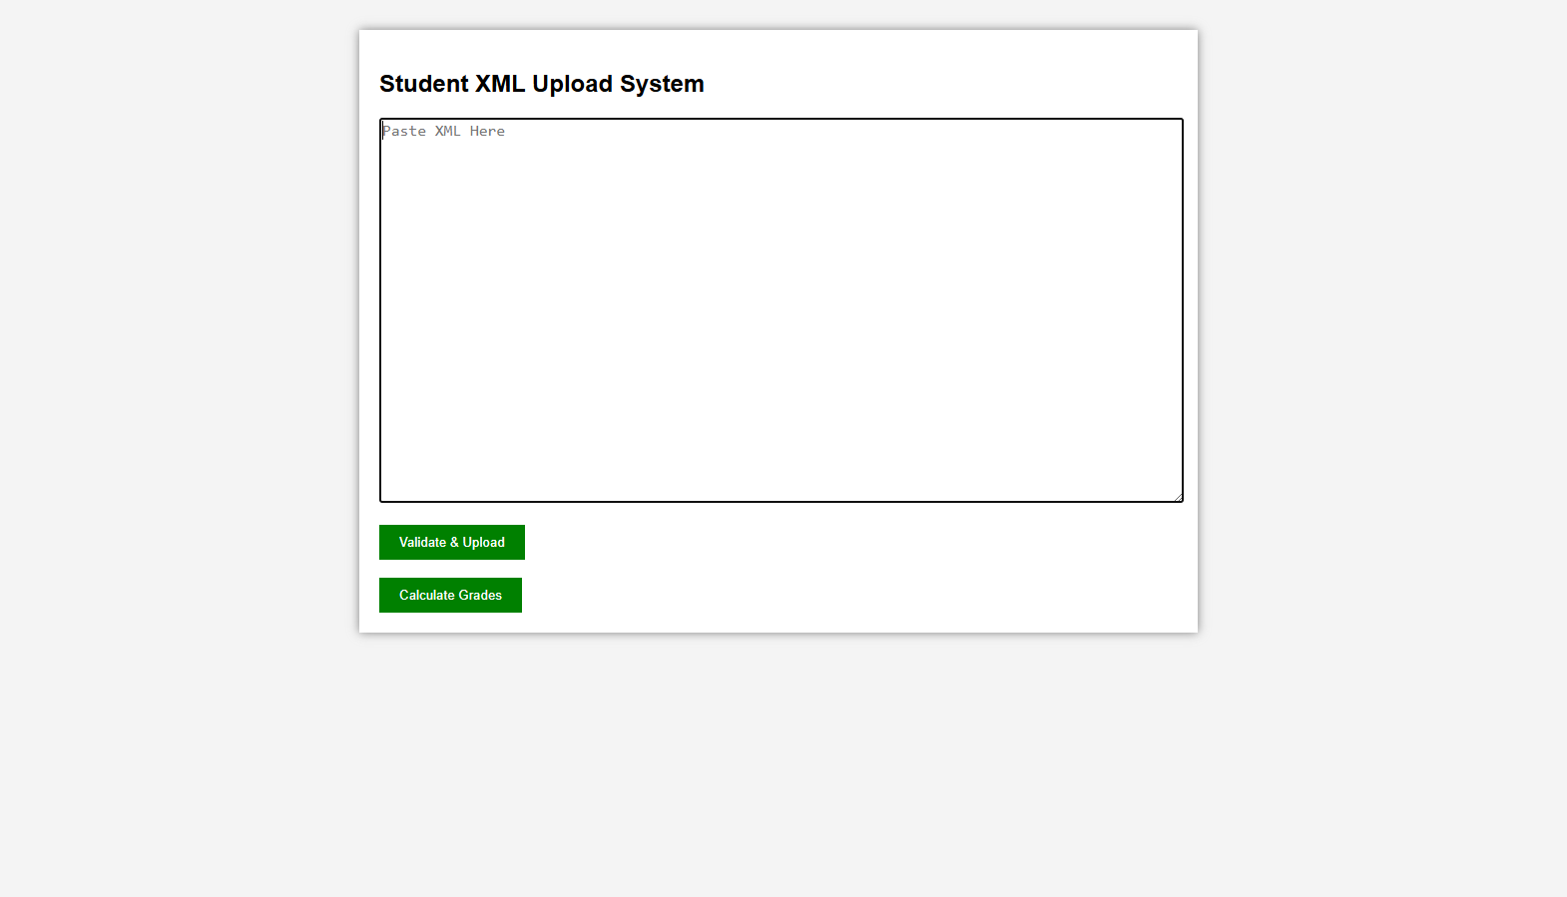

- Now, pasting the correct validation of xml file and then validating
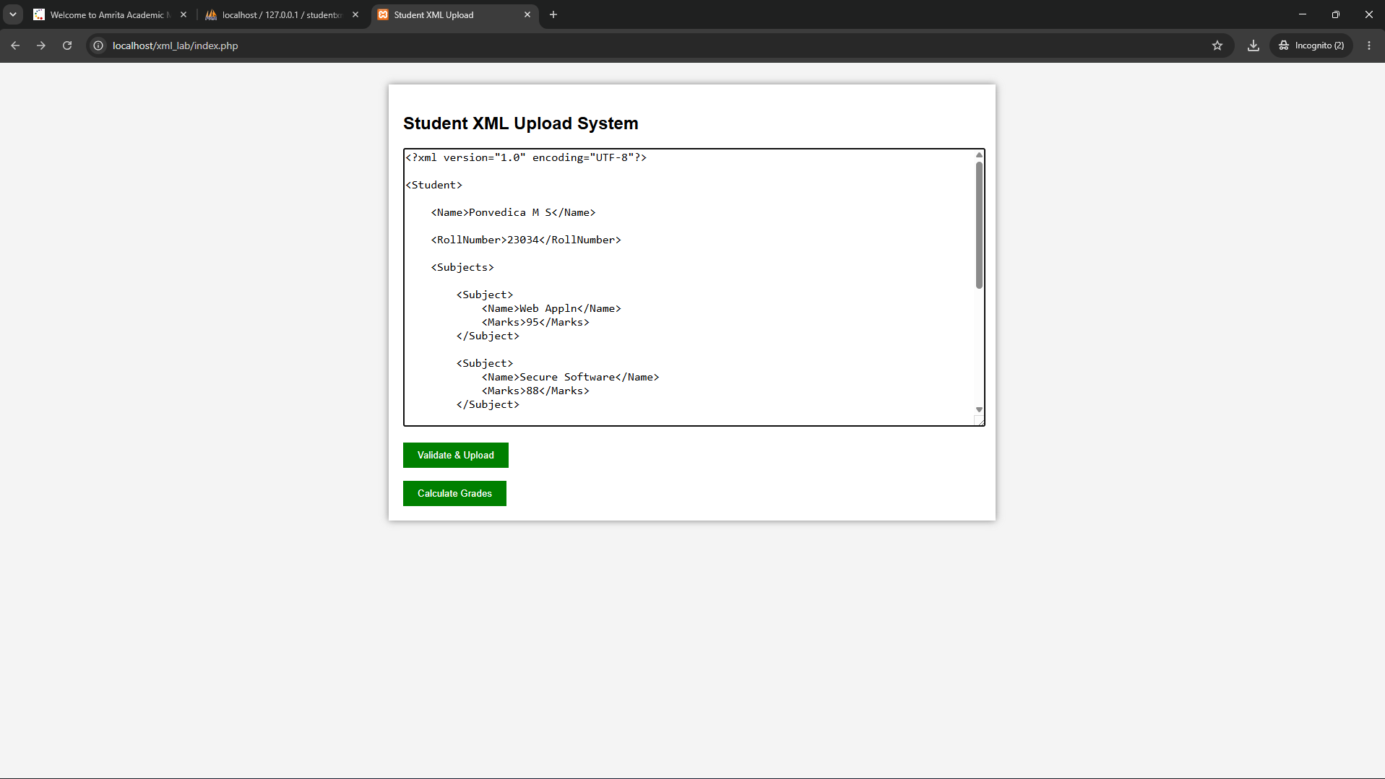
- Since, it is well formed it is validated and the data are uploaded to the database successfully
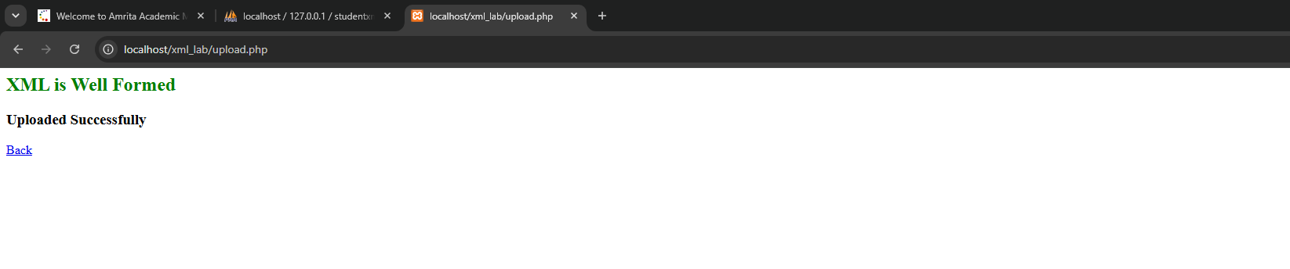
- Now, if we click the calculate grades, it calculates and display it.
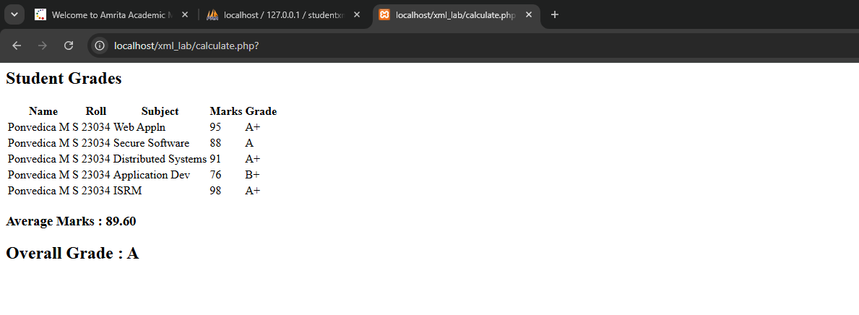

- We can see the reflected data in the database
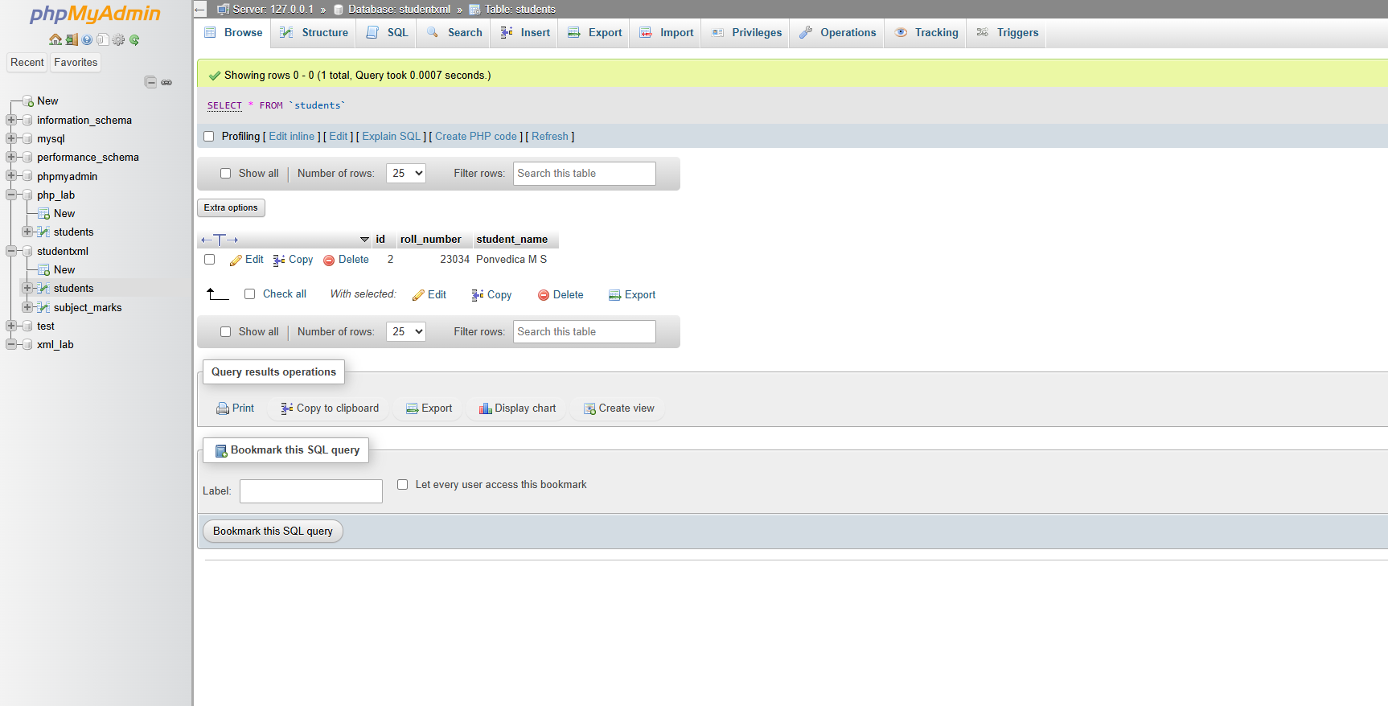
- Not well formed xml is pasted to check for validation
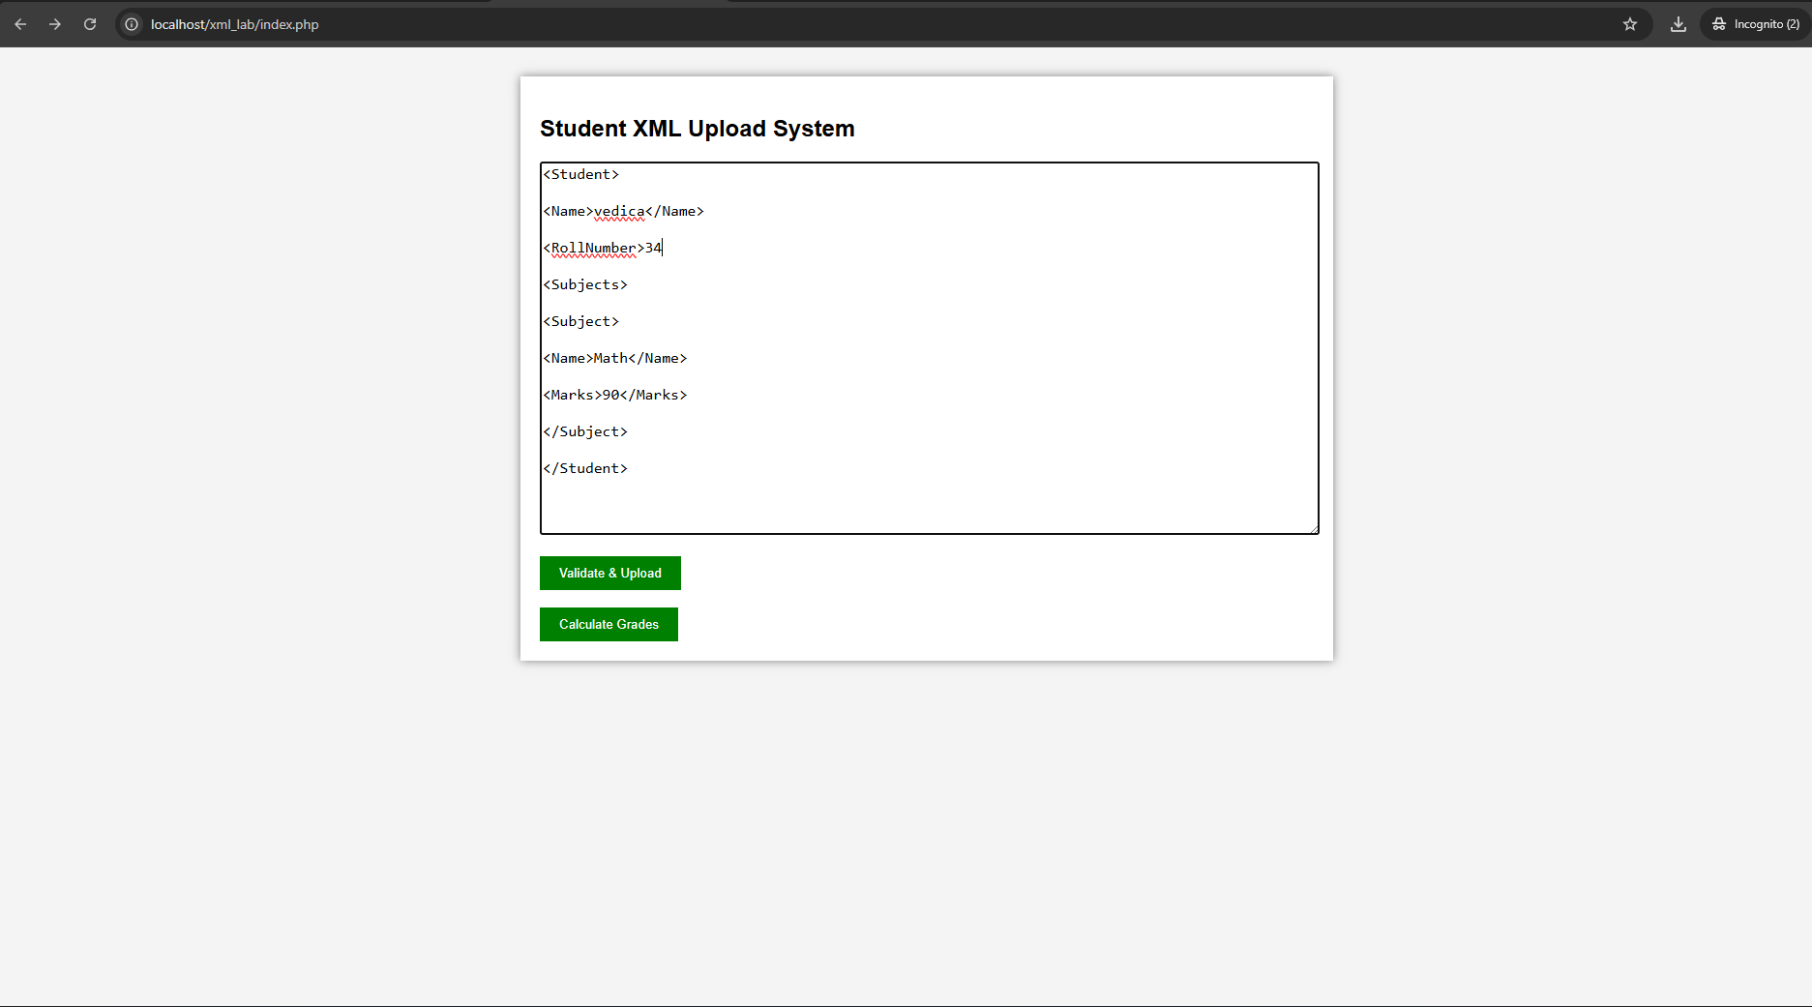

- It displays the Error and mentions what error it is
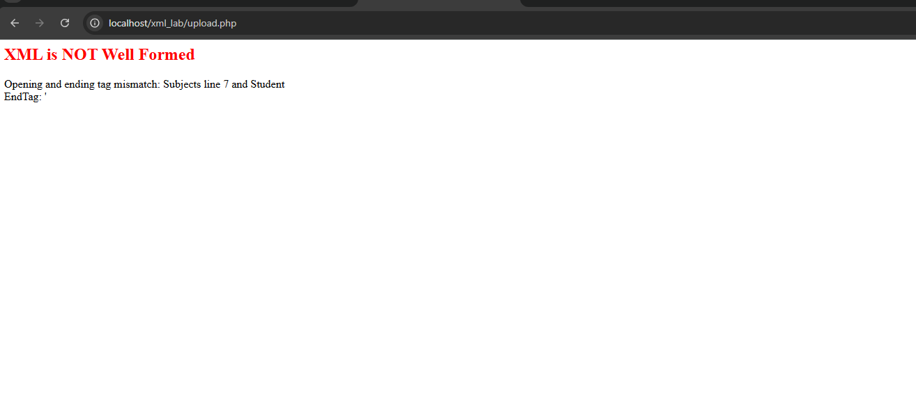
- XSD validation also included now. – I added new .xsd file and then changed some code with respect to upload.php
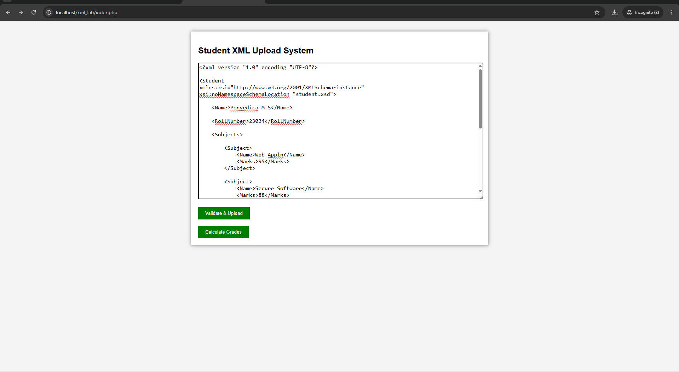
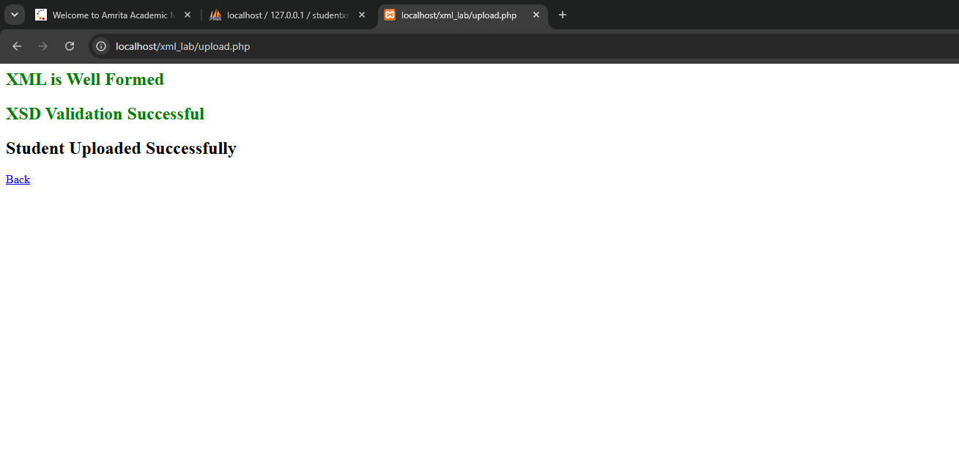
- Not well formed xsd but validated xml
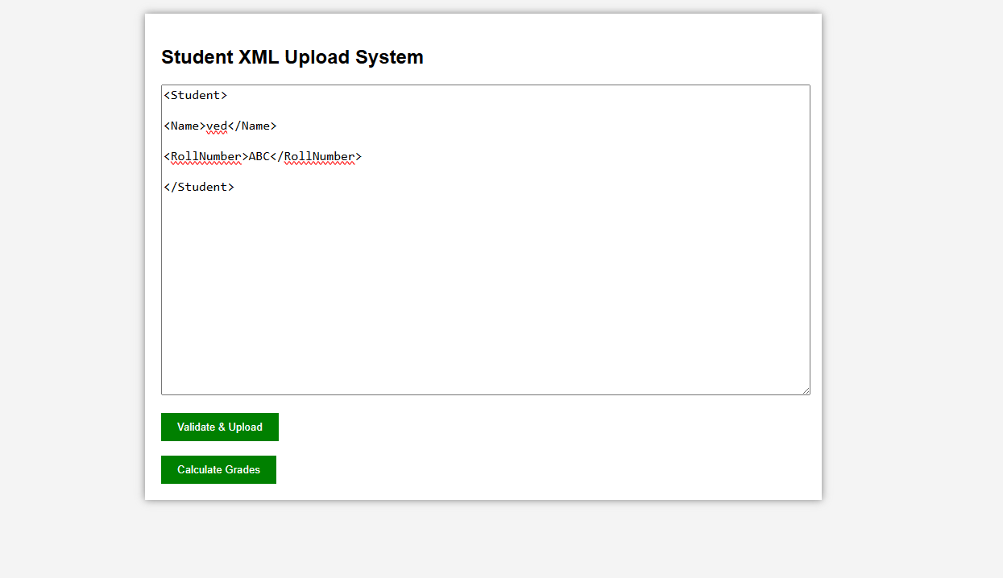
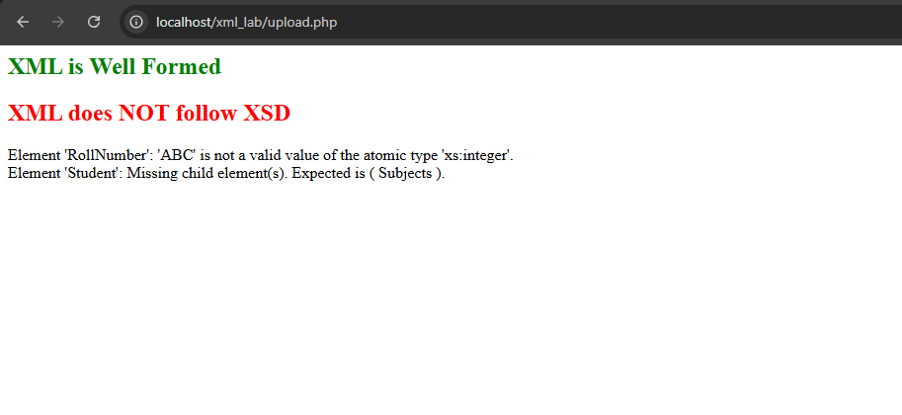
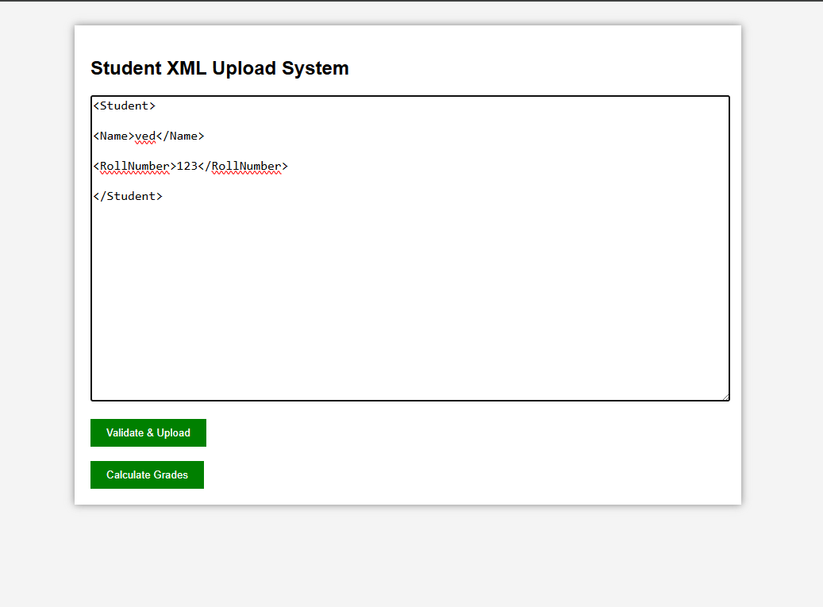
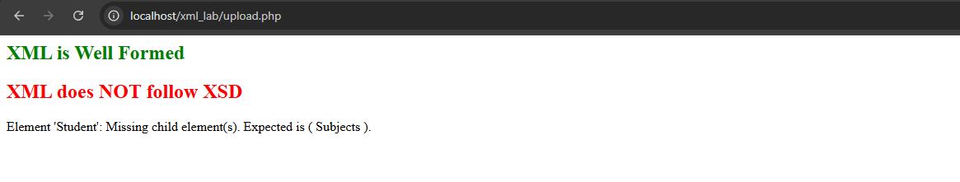

Codes :
SQL queries
CREATE DATABASE studentxml;

USE studentxml;

CREATE TABLE students (
id INT AUTO_INCREMENT PRIMARY KEY,
roll_number INT UNIQUE,
student_name VARCHAR(100)
);

CREATE TABLE subject_marks (
id INT AUTO_INCREMENT PRIMARY KEY,
student_id INT,
subject_name VARCHAR(100),
marks INT,
grade VARCHAR(5),
FOREIGN KEY(student_id) REFERENCES students(id)
);

Calculate.php
<?php

include("db.php");

$result=$conn->query("SELECT students.student_name,
students.roll_number,
subject_marks.*

FROM students

JOIN subject_marks

ON students.id=subject_marks.student_id");

echo "<h2>Student Grades</h2>";

echo "<table>";

echo "<tr>

<th>Name</th>

<th>Roll</th>

<th>Subject</th>

<th>Marks</th>

<th>Grade</th>

</tr>";

$total=0;

$count=0;

while($row=$result->fetch_assoc())
{

$marks=$row['marks'];

if($marks>=90)
$grade="A+";

else if($marks>=80)
$grade="A";

else if($marks>=70)
$grade="B+";

else if($marks>=60)
$grade="B";

else if($marks>=50)
$grade="C";

else if($marks>=40)
$grade="D";

else
$grade="F";

$conn->query("UPDATE subject_marks
SET grade='$grade'
WHERE id=".$row['id']);

echo "<tr>";

echo "<td>".$row['student_name']."</td>";

echo "<td>".$row['roll_number']."</td>";

echo "<td>".$row['subject_name']."</td>";

echo "<td>".$marks."</td>";

echo "<td>".$grade."</td>";

echo "</tr>";

$total+=$marks;

$count++;}

echo "</table>";

$avg=$total/$count;

echo "<h3>Average Marks : ".number_format($avg,2)."</h3>";

if($avg>=90)
$overall="A+";
else if($avg>=80)
$overall="A";
else if($avg>=70)
$overall="B+";
else if($avg>=60)
$overall="B";
else if($avg>=50)
$overall="C";
else if($avg>=40)
$overall="D";
else
$overall="F";

echo "<h2>Overall Grade : $overall</h2>";

?>

Db.php
<?php

$host="localhost";
$user="root";
$password="";
$dbname="studentxml";
$conn = new mysqli($host,$user,$password,$dbname);

if($conn->connect_error)
{ die("Connection Failed : ".$conn->connect_error);}

?>

Index.php
<!DOCTYPE html>
<html>

<head>

<title>Student XML Upload</title>

<link rel="stylesheet" href="style.css">

</head>

<body>

<div class="container">

<h2>Student XML Upload System</h2>

<form action="upload.php" method="post">

<textarea name="xml" rows="20" cols="80"
placeholder="Paste XML Here"></textarea>

<br><br>

<input type="submit" value="Validate & Upload">

</form>

<br>

<form action="calculate.php">

<input type="submit" value="Calculate Grades">

</form>

</div>

</body>

</html>

Invalid xml
<Student>

<Name>Vedica</Name>

<RollNumber>34

<Subjects>

<Subject>

<Name>Math</Name>

<Marks>90</Marks>

</Subject>

</Student>

Valid xml
<?xml version="1.0" encoding="UTF-8"?>

<Student
xmlns:xsi="http://www.w3.org/2001/XMLSchema-instance"
xsi:noNamespaceSchemaLocation="student.xsd">

<Name>Ponvedica M S</Name>

<RollNumber>23034</RollNumber>

<Subjects>

<Subject>
<Name>Web Appln</Name>
<Marks>95</Marks>
</Subject>

<Subject>
<Name>Secure Software</Name>
<Marks>88</Marks>
</Subject>

<Subject>
<Name>Distributed Systems</Name>
<Marks>91</Marks>
</Subject>

<Subject>
<Name>Application Dev</Name>
<Marks>76</Marks>
</Subject>

<Subject>
<Name>ISRM</Name>
<Marks>98</Marks>
</Subject>

</Subjects>

</Student>

css
body{

font-family:Arial;

background:#f4f4f4;

}

.container{

width:800px;

margin:auto;

background:white;

padding:20px;

margin-top:30px;

box-shadow:0px 0px 10px gray;

}

textarea{

width:100%;

font-size:16px;

}

input[type=submit]{

padding:10px 20px;

background:green;

color:white;

border:none;

cursor:pointer;

}

table{

width:100%;

border-collapse:collapse;

margin-top:20px;

}

table,th,td{

border:1px solid black;

padding:10px;

}

Upload.php
<?php

include("db.php");

libxml_use_internal_errors(true);

$xmlString = $_POST['xml'];

$dom = new DOMDocument();

if (!$dom->loadXML($xmlString)) {

echo "<h2 style='color:red'>XML is NOT Well Formed</h2>";

foreach(libxml_get_errors() as $error){
echo $error->message."<br>";
}

exit();
}

echo "<h2 style='color:green'>XML is Well Formed</h2>";

if(!$dom->schemaValidate("student.xsd"))
{
echo "<h2 style='color:red'>XML does NOT follow XSD</h2>";

foreach(libxml_get_errors() as $error){
echo $error->message."<br>";
}

exit();
}

echo "<h2 style='color:green'>XSD Validation Successful</h2>";

$xml = simplexml_load_string($xmlString);

$name = (string)$xml->Name;
$roll = (int)$xml->RollNumber;

$conn->query("INSERT INTO students(student_name,roll_number)
VALUES('$name','$roll')");

$student_id = $conn->insert_id;

foreach($xml->Subjects->Subject as $subject)
{

$subjectName = (string)$subject->Name;
$marks = (int)$subject->Marks;

$conn->query("INSERT INTO subject_marks(student_id,subject_name,marks)
VALUES($student_id,'$subjectName',$marks)");
}

echo "<h2>Student Uploaded Successfully</h2>";

echo "<a href='index.php'>Back</a>";
?>

